**Installing Bootstrap**

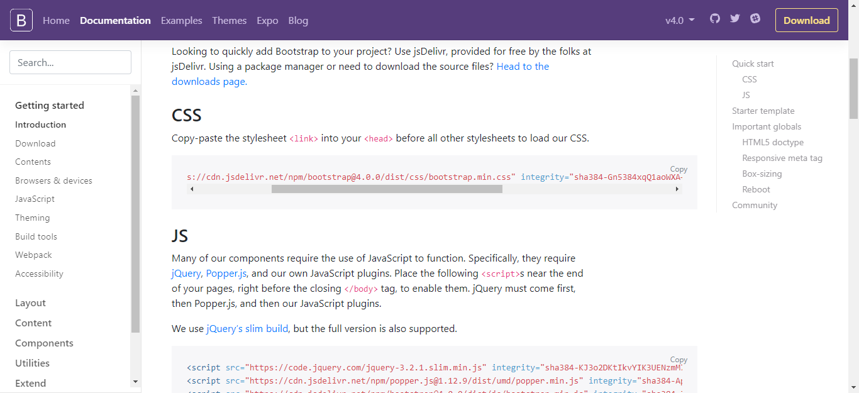

Copy CSS link and paste in stylesheet.

<link rel="stylesheet" href="https://cdn.jsdelivr.net/npm/bootstrap@4.0.0/dist/css/bootstrap.min.css" integrity="sha384-Gn5384xqQ1aoWXA+058RXPxPg6fy4IWvTNh0E263XmFcJlSAwiGgFAW/dAiS6JXm" crossorigin="anonymous">

<link rel="stylesheet" href=<https://cdn.jsdelivr.net/npm/bootstrap@4.0.0/dist/css/bootstrap.min.css> crossorigin="anonymous">

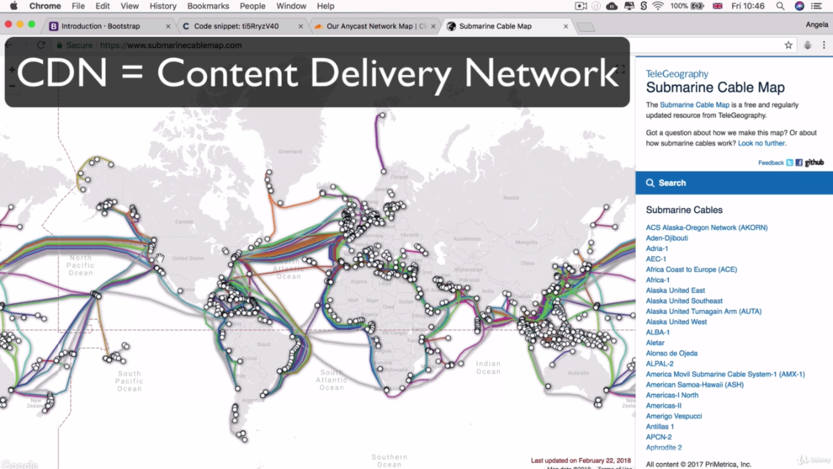

<https://www.submarinecablemap.com/> Above website link

Cloudfare network: <https://www.cloudflare.com/network/>

Maxcdn.com: <https://www.stackpath.com/maxcdn/>

**Code:**

<!DOCTYPE html>

<html lang="en" dir="ltr">

<head>

<meta charset="utf-8">

<title>Bootstrap Installation</title>

<link rel="stylesheet" href="https://cdn.jsdelivr.net/npm/bootstrap@4.0.0/dist/css/bootstrap.min.css"

integrity="sha384-Gn5384xqQ1aoWXA+058RXPxPg6fy4IWvTNh0E263XmFcJlSAwiGgFAW/dAiS6JXm" crossorigin="anonymous">

</head>

<body>

<h1>Hello World!</h1>

</body>

</body>

</html>

Starter template

Be sure to have your pages set up with the latest design and development standards. That means using an HTML5 doctype and including a viewport meta tag for proper responsive behaviors. Put it all together and your pages should look like this:

<!doctype html>

<html lang="en">

<head>

<!-- Required meta tags -->

<meta charset="utf-8">

<meta name="viewport" content="width=device-width, initial-scale=1, shrink-to-fit=no">

<!-- Bootstrap CSS -->

<link rel="stylesheet" href="https://cdn.jsdelivr.net/npm/bootstrap@4.0.0/dist/css/bootstrap.min.css" integrity="sha384-Gn5384xqQ1aoWXA+058RXPxPg6fy4IWvTNh0E263XmFcJlSAwiGgFAW/dAiS6JXm" crossorigin="anonymous">

<title>Hello, world!</title>

</head>

<body>

<h1>Hello, world!</h1>

<!-- Optional JavaScript -->

<!-- jQuery first, then Popper.js, then Bootstrap JS -->

<script src="https://code.jquery.com/jquery-3.2.1.slim.min.js" integrity="sha384-KJ3o2DKtIkvYIK3UENzmM7KCkRr/rE9/Qpg6aAZGJwFDMVNA/GpGFF93hXpG5KkN" crossorigin="anonymous"></script>

<script src="https://cdn.jsdelivr.net/npm/popper.js@1.12.9/dist/umd/popper.min.js" integrity="sha384-ApNbgh9B+Y1QKtv3Rn7W3mgPxhU9K/ScQsAP7hUibX39j7fakFPskvXusvfa0b4Q" crossorigin="anonymous"></script>

<script src="https://cdn.jsdelivr.net/npm/bootstrap@4.0.0/dist/js/bootstrap.min.js" integrity="sha384-JZR6Spejh4U02d8jOt6vLEHfe/JQGiRRSQQxSfFWpi1MquVdAyjUar5+76PVCmYl" crossorigin="anonymous"></script>

</body>

</html>